Media Piece Suggestions

Authors: Monika Roznere and Andy Bean

ToC:

**PAPER MEDIA CAMPAIGN**

As stated in the final assignment description, the paper media campaign option includes at least a poster, a pamphlet, and a 1-minute elevator pitch. A social media account can also be tied to this.

Pamphlet Examples:

* 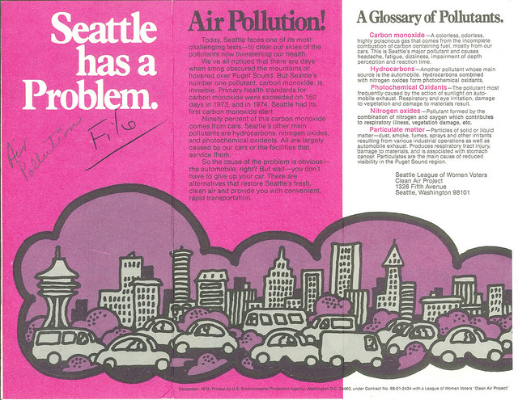This pamphlet was produced by the EPA in 1974! You probably want to include more information than this, but it may inspire you where to start.
* 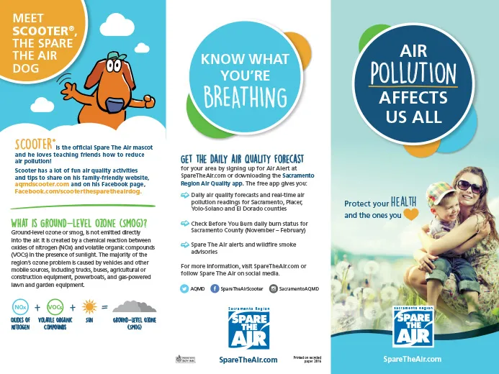Newer pamphlets may look more like this. Note the logo, link to a website, and clear and cohesive graphics.
* (Add more suggestions!)

Poster Examples:

* 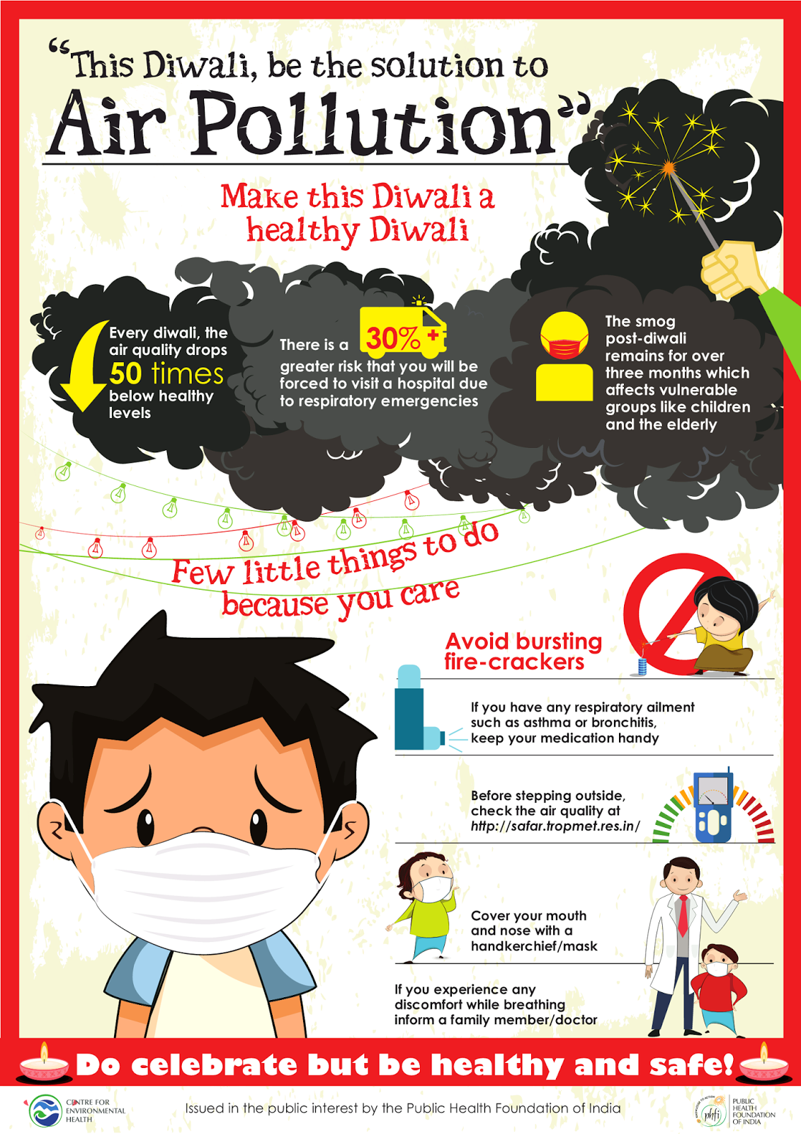You may consider slogans and including what actions people should take like this, but remember to also back it up with your research! And make the poster graphics match the pamphlet.
* (Add more suggestions!)

**DIGITAL MEDIA CAMPAIGN**

As noted in the final project description, the digital media campaign includes at least a website and an example ad that could be run online to link to that website. A social media account can also be tied to this website

Website examples:

* <https://350.org/> Consider how a public interest group’s website might inspire you if you want to inspire people to advocate for this issue in policy
  + See also: <https://www.sunrisemovement.org/>
  + <https://www.sierraclub.org/>
  + <https://resphealth.org/>
* <https://www.weather.gov/cle/lakeeriehab> This is a government website, but consider how the site explains the research conducted and teaches visitors to read the graphics that they have presented
* (Add more suggestions!)

Ad examples:

* 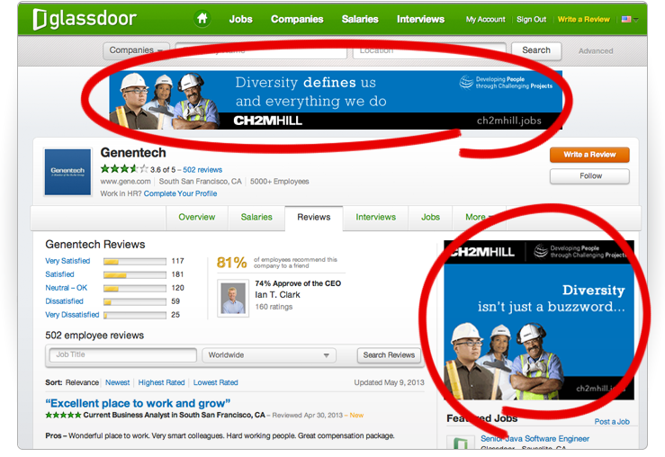You might consider making a single graphic that can be scaled to multiple uses (square ad and banner ad, for example)
* 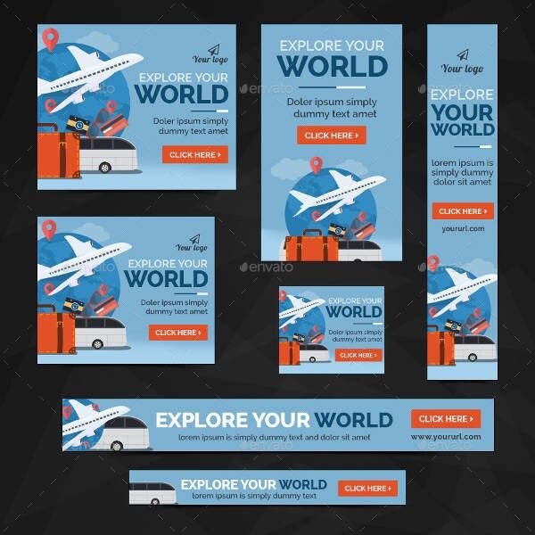Even more size possiblities
* (Add more suggestions!)

**PODCAST OR RADIO INTERVIEW**

As noted in the final assignment description, the radio or podcast segment should be 5-10 minutes in length, and probably involves an interview with a researcher (though it doesn’t have to).

Podcast Examples:

* The best example for scientific storytelling I would recommend is RadioLab!
  + <https://www.wnycstudios.org/podcasts/radiolab/podcasts>
  + Also consider kids version: <https://www.wnycstudios.org/podcasts/radiolab-kids>
  + You can honestly pick any episode and probably learn something new, but if you want a recommendation, I would say go to something perhaps like this episode: <https://www.wnycstudios.org/podcasts/radiolab/articles/return-alpha-gal> which combines a current event with a previous story and the research related to that.
* You might also consider Hidden Brain or Invisibilia, two podcasts related to psychology and human behavior. They also hold interviews with guests to discuss their research.
  + <https://hiddenbrain.org/>
  + <https://www.npr.org/programs/invisibilia/>
* (Add more suggestions!)

Radio Examples:

* Something short like Short Wave may be good inspiration
  + <https://www.npr.org/2022/02/10/1079990248/twinkle-twinkle-shooting-star>
* Or a short one-off national story (most common for a radio format)
  + <https://www.npr.org/2022/02/22/1082118865/soot-is-accelerating-snow-melt-in-popular-parts-of-antarctica-study-finds>
* (Add more suggestions!)

**COMMERCIAL OR DOCUMENTARY**

As described in the final assignment, the video or tv commercial should be about 3-5 minutes in length. It could be a slide show with narration, a mini-documentary, or an ad running prior to a youtube video.

Documentary-type Examples:

* If you like RadioLab, consider checking out this series on Netflix by Latif Nasser
  + <https://www.netflix.com/search?q=connected&jbv=81031737> The episode on dust is most related to air quality!
* Bill Nye saves the world is another option, and would cater more to kid audiences. Look to the individual segments where one of his team goes out into the field to delve deeper in a specific topic, less of the live-show demonstrations (though maybe these are helpful to explain a point of yours!)
  + <https://www.netflix.com/search?q=bill%20nye&jbv=80117748>

Ad-type Examples:

* A “Jetsons” PSA from 1990: <https://www.youtube.com/watch?v=YXNeeNEOEYE>
* Though I suppose *don’t* do this: <https://www.thesun.co.uk/tech/5299010/dyson-purifier-banned-tv-ad/>